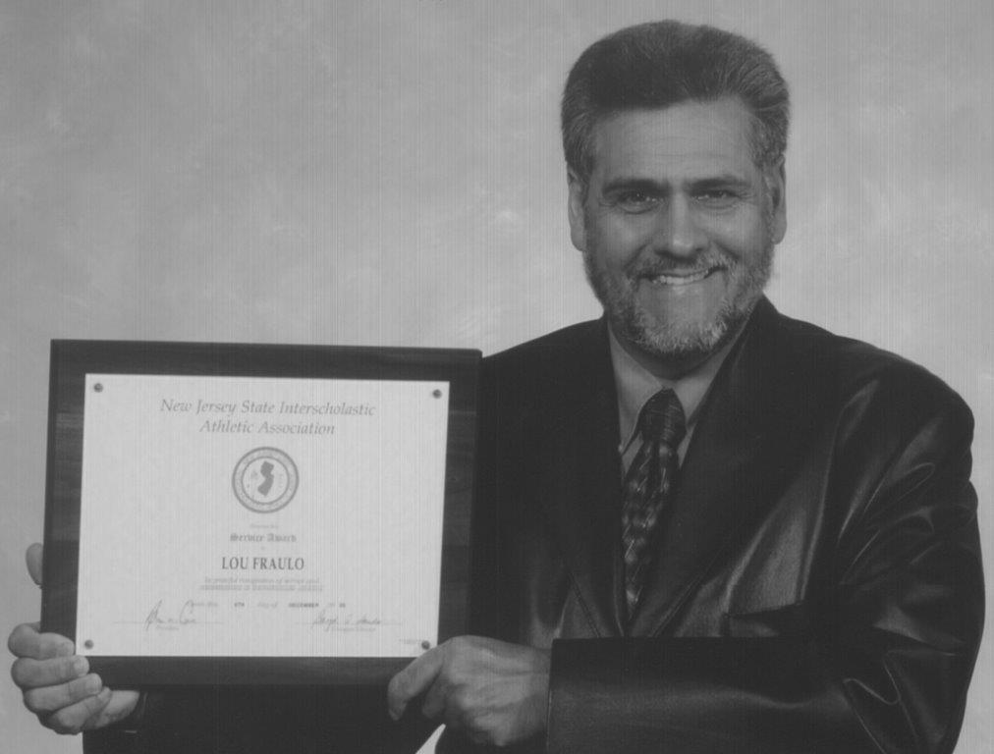Lou Fraulo XC Invitational

DATE: Saturday, October 22, 2022
TIME: First Race At: 9:00 AM
SITE: Garret Mountain

Fees: $70 per team (up to 7) / $15 per individual
Team Awards: Plaque for winning team, and 7 medals to top 3 teams in Varsity Races.
Individual Awards: Medals to top 25 individuals in ALL races.

RACE SCHEDULE
[Pod 1- Large schools] [Pod 2-Small Schools]
9:00 am Frosh Boys & Girls (COMBINED) 11:30 am
9:10 am Varsity Boys 11:40 am
9:25 am Varsity Girls 11:55 am
9:40 am JV Boys 12:10 pm
9:55 am JV Girls 12:25 pm

Pod 1 schools must leave by 10:30 ! / Pod 2 schools arrive by 10:45
This XC Meet is being held in Honor of Coach Louis Fraulo. During his time as a Coach, Official and Meet Director – he helped to grow and improve Cross Country both in Passaic County, as well as the entire state of NJ. From organizing meets, introducing and implementing Fully Automatic Timing, to recruiting officials, Coaching the sport to untold athletes regardless of whether or not they were on his teams, and ultimately – doing what is right for the athletes – Coach Fraulo left an indelible mark on the sport. It is only fitting that we celebrate his achievement by hosting a Cross Country meet in his honor at the park that he spent innumerable hours at!!

Meet Information

- Schools will be placed in boxes at the starting line

- We are using NJ Mile Split to enter your rosters and declare that you are coming to the meet. All you have to do is enter your ENTIRE (that are running) team into the Meet Collection. *Note* password to the online entry will be provided once your entry form and Insurance forms are received! Click here to get to the meet

- Coaches please run your top seven in the Varsity Race before entering the J-V races.

- Bring PINS!!!!

- Entries are due: Wed October 19, 2022

- Make check payable to: LFRacing LLC

- Questions call: 201-632-3709 Victor Wu

Remember to Enter on MileSplit & send your forms in!

You MUST send in your school’s insurance certificate naming the Passaic County Parks Department as additionally insured and the certificate holder.

Passaic County Parks Department 209 Totowa Road Wayne, NJ 07470

Lou Fraulo XC Invitational

Information: 1. Entry Fee: $70.00 per team $15.00 per individual
*Note: Must enter individuals in Varsity before JV!!!
2. Checks payable to: LFRacing LLC

School ___________________________________________________________

Coach ___________________________________________________________

Coach’s Cell ____________________ Coach’s Email _________________________

- Boys # of teams # of individuals

FROSH ________ ________

J.V. ________ ________

VARSITY ________ ________

- Girls FROSH ________ ________

J.V. ________ ________

VARSITY ________ ________

TOTAL # OF TEAMS _______ X $70.00 = ________

TOTAL # OF INDIVIDUALS ______ X $15.00 = ________

TOTAL ENTRY = ________

Entry must be received by Wed October 19, 2022

Mail Entry to: LFRacing LLC Email: lfracingcontact@gmail.com
18 Claremont Ave
Montclair, NJ 07042

